Assignment performed by Gaurav Amarnani from DSE CMPN.
CG LAB 3 - Implement Flood Fill and Boundary Fill Algorithm.

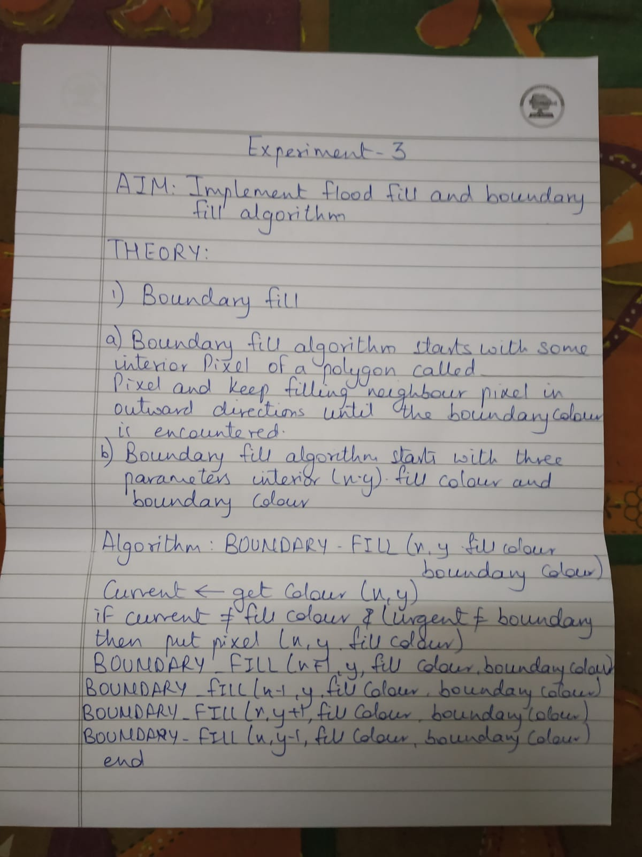

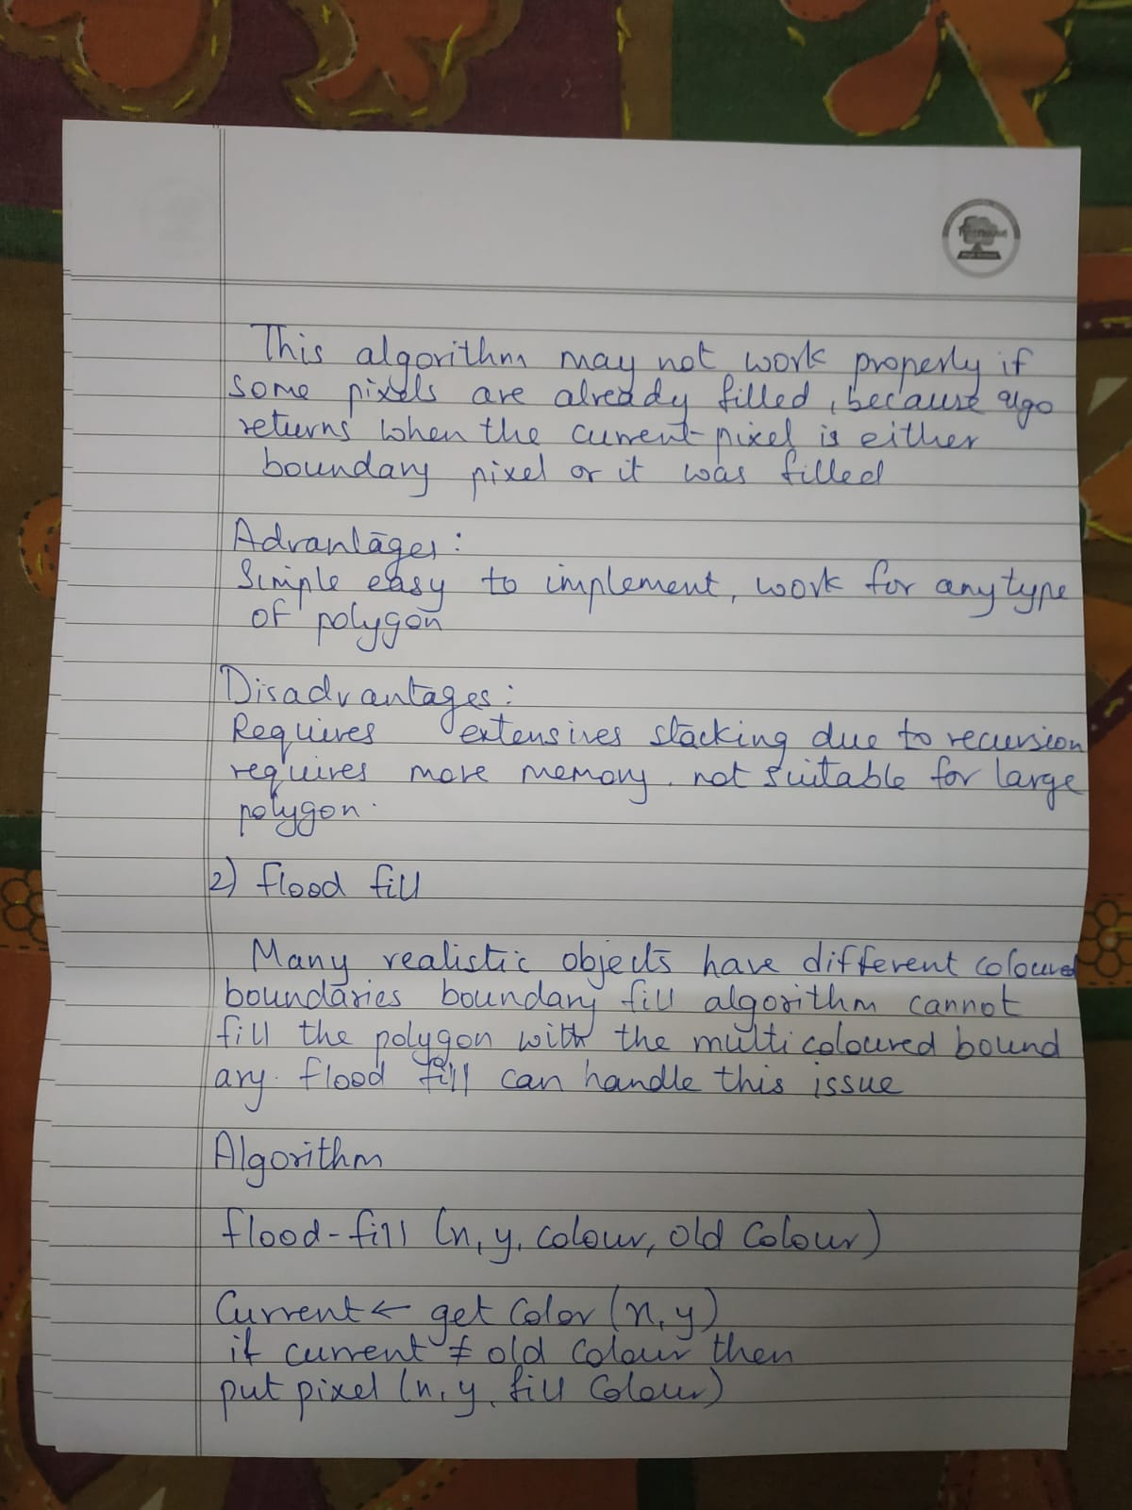

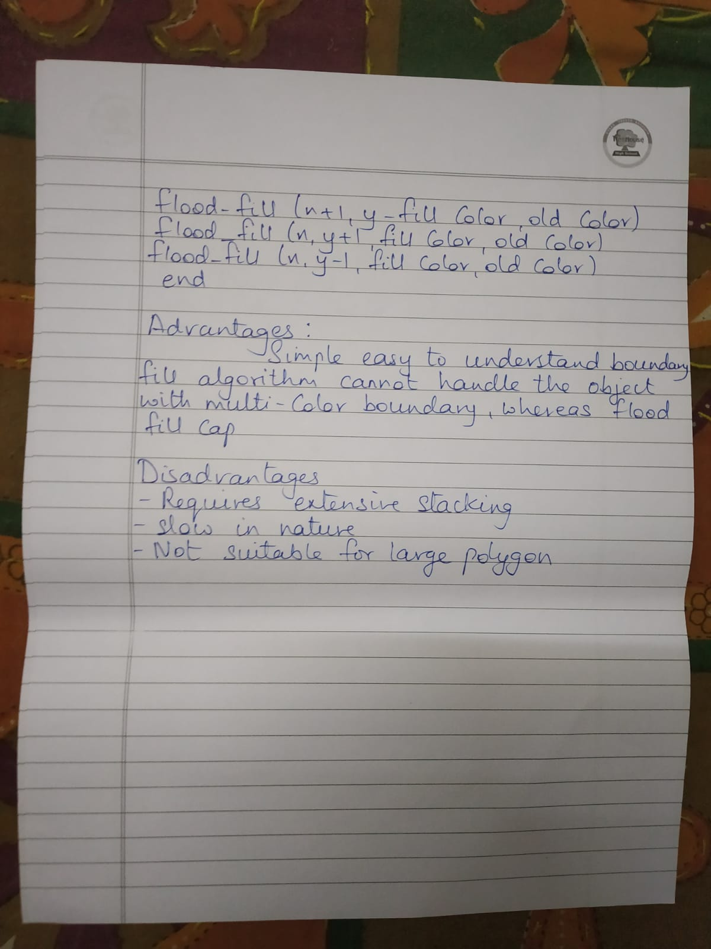

Program:

#include <graphics.h>

//Performed by Gaurav Amarnani DSE CMPN.

void boundaryFill4(int x, int y, int fill_color,int boundary_color) {

if(getpixel(x, y) != boundary_color && getpixel(x, y) != fill_color) {
putpixel(x, y, fill_color);
boundaryFill4(x + 1, y, fill_color, boundary_color);
boundaryFill4(x, y + 1, fill_color, boundary_color);
boundaryFill4(x - 1, y, fill_color, boundary_color);
boundaryFill4(x, y - 1, fill_color, boundary_color);
}
}

void flood(int x, int y, int oldcol, int newcol) {

if(getpixel(x,y) == oldcol) {
putpixel(x,y,newcol);
delay(1);
flood(x+1,y,oldcol,newcol);
flood(x,y+1,oldcol,newcol);
flood(x-1,y,oldcol,newcol);
flood(x,y-1,oldcol,newcol);
}
}

void main() {
int gd = DETECT, gm;
int x,y,radius,x1,y1,x2,y2,ch;
initgraph(&gd, &gm, "c:\\turboc3\\bgi");
printf("Select one option:\n1. Boundary Fill\n2. Flood Fill\n");
scanf("%d",&ch);
switch(ch) {
case 1:
printf("\nEnter x1, y1, x2, y2: ");
scanf("%d %d %d %d",&x1,&y1,&x2,&y2);
rectangle(x1, y1, x2, y2);
boundaryFill4((x1+1), (y1+1), 4, 15);
break;

case 2:
printf("\nEnter the radius: ");
scanf("%d",&radius);
printf("\nEnter x and y: ");
scanf("%d %d",&x,&y);
circle(x,y,radius);
flood(x,y,0,15);
break;

default:
printf("Enter valid option.");
break;
}
getch();
closegraph();
}

Output:
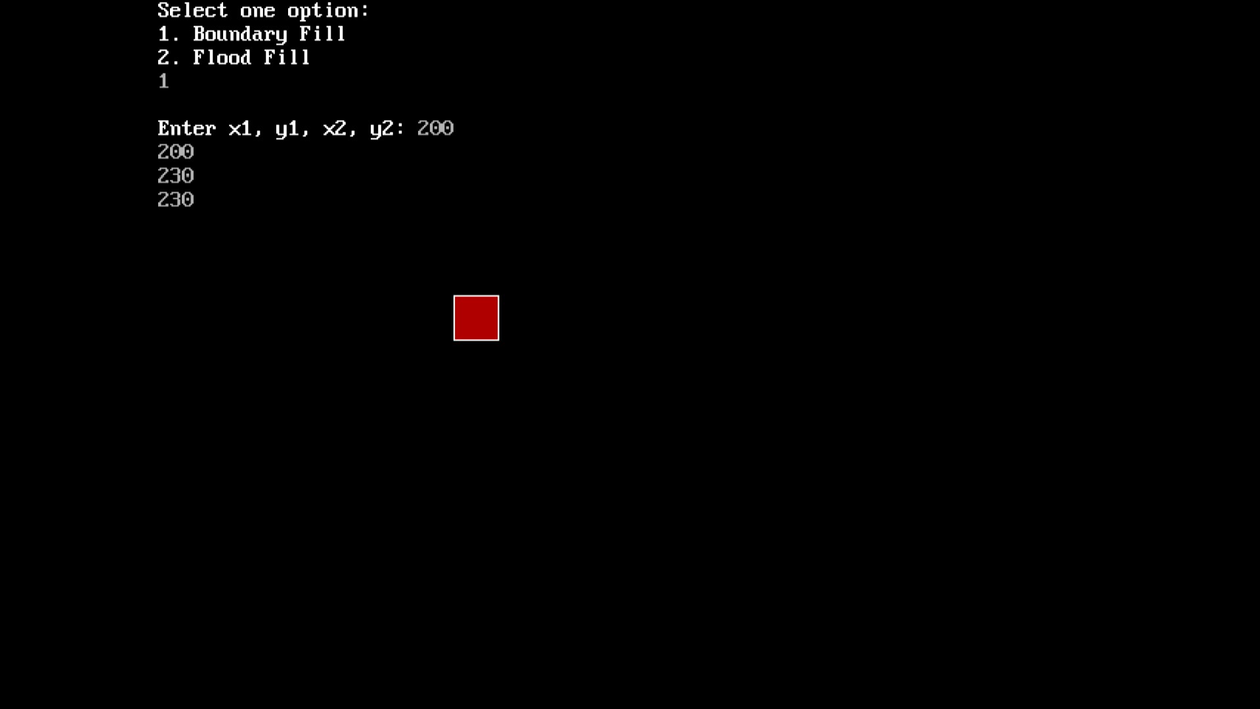

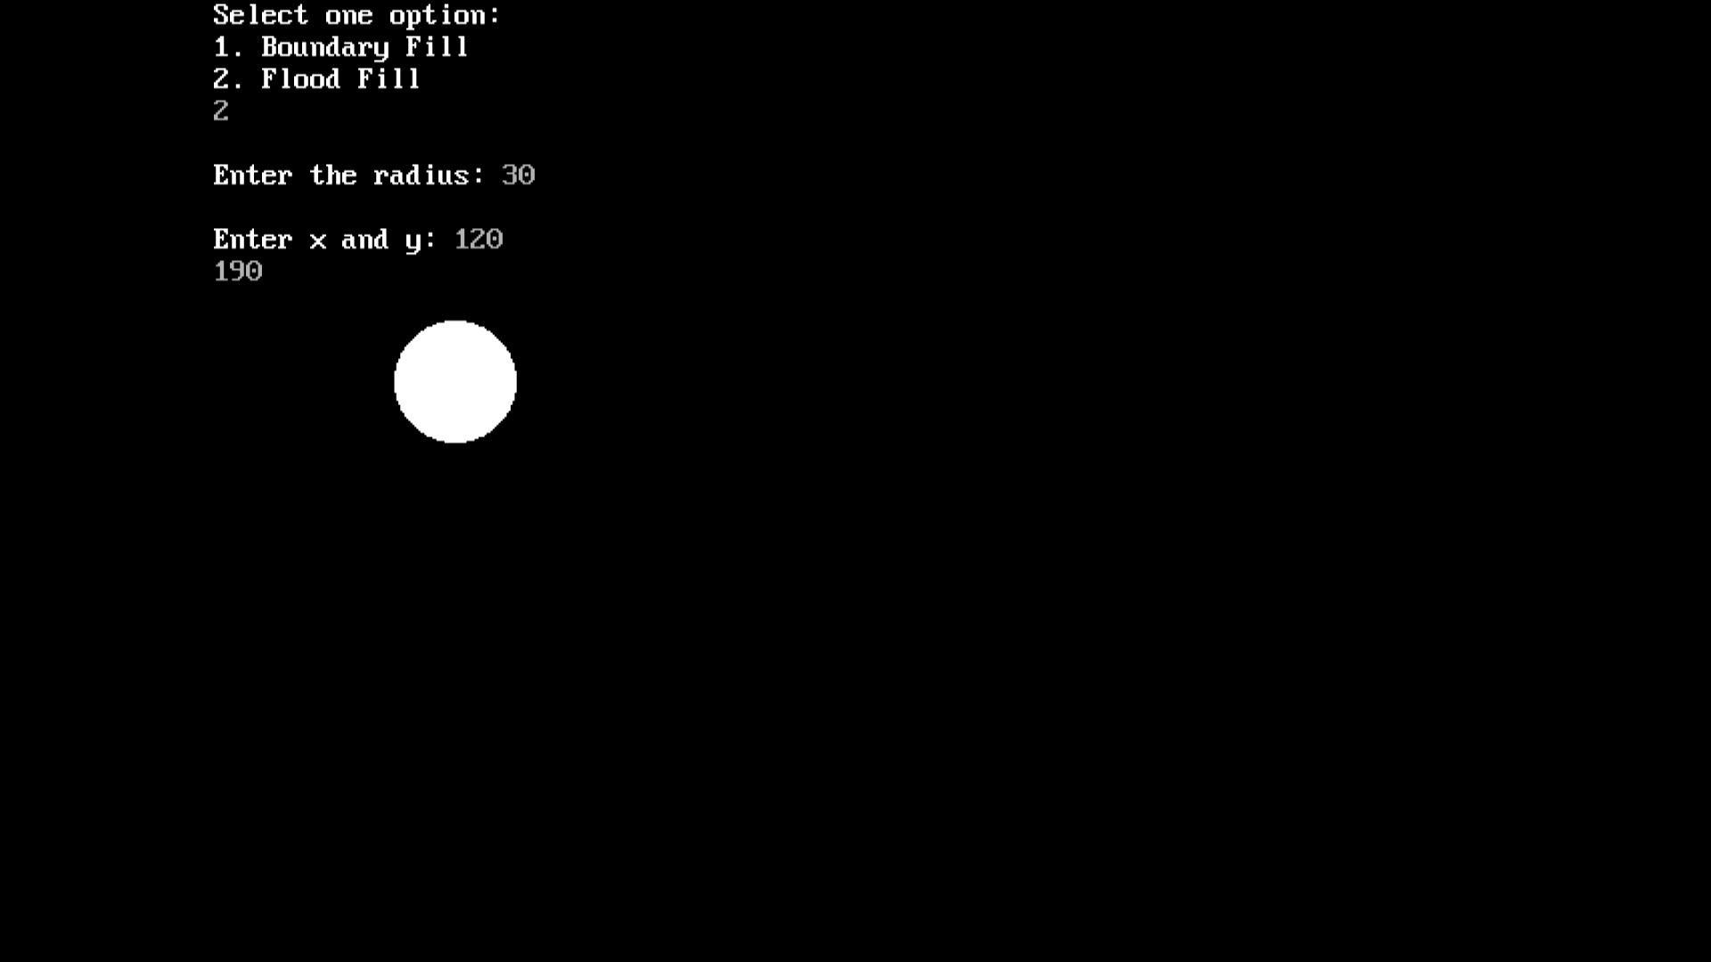

Conclusion:

